Summary of the teaching staff
Full name: Baimadieva Galiya Adelbakimovna
Education:
 | Higher, 1966-1972 Kazakh State University named after Kirov, Almaty
 | In 2003 Candidate of Pedagogical Sciences, 13.00.02- Theory and Methods of Teaching and Education (Mathematics)
 | Mathematician. Mathematics teacher.
Work experience:
Academic:
Work in this organization
From 2018 to present, Kazakh University of Technology and Business.
Ass.Professor of the Department of Information Technology.
 | List of taught disciplines: Mathematics 1,2,3. Higher Mathematics. Discrete Math
 | Employment - full time
Previous jobs in educational organizations:
1972-2007 Lecturer, Head of the Department, Dean of the Natural Pedagogical Faculty of the Ar State Pedagogical Institute named after I. Altynsarin,
2007-2008 Deputy Director of the Scientific and Practical Center for the Problems of 12-Year Education of the Ministry of Education and Science of the Republic of Kazakhstan,
From 2008 - 2018 - Associate Professor of the Department of Higher Mathematics of L.N. Gumilyov Eurasian National University.
 | List of taught disciplines: Mathematics 1,2,3. Higher Mathematics. Discrete Math
 | Employment - full time
Non - academic:
 | --
 | Brief description of the position
 | Employment - full
Professional development:
 | 01.11.21-14.11.21 Organization of research activities, Best Innovation Group Inc.
Membership in professional organizations:
 | Since 1972
Awards and prizes:
 | Honorary diploma of the Ministry of Education and Science of the Republic of Kazakhstan
Activities in the service sector: no
 | (Inside and outside the institution)
Publications and presentations:
Period: | 2018-2022
№ | Name | Printed or as a manuscript | Publisher, magazine, (title, year, page number) Copyright certificate, patent number | Number of printed sheets | FULL NAME of  co-authors
1 | 2 | 3 | 4 | 5 | 6
1 | Zhogary mathematics. I. | printed | Textbook. "Evero" baspasy. Almaty kalasy, 2018. 308 p. ISBN 978-601-327-369-3 | 19,2 | Bazarbayeva G.S. Rayhan M.
2 | Zhogary mathematics. II. | printed | Textbook..- Astana, 2019. 251 p.  ISBN 978-601-337-079-8 | 15,7 | Bazarbayeva G.S. Rayhan M.
3 | Training of teachers for mastering new pedagogical innovative technologies | printed | Materials of the international scientific and practical conference. Aktobe, 2019.P. 360-364. | 0,25 | Bazarbayeva G.S. Idirisov K.M.
4 | Higher mathematics. Part I. | electronic textbook | Electronic textbook  No. 2481 copyright certificate dated. 2019.03.28. | 16,2 | Bazarbayeva G.S. Rayhan M.
5 | Higher mathematics. Part II | electronic textbook | Electronic textbook  No. 3675 copyright certificate dated. 2019.05.22. | 16,2 | Bazarbayeva G.S. Rayhan M.  Idirisov K.M.  Idirisov Zh
6 | Organization of independent work of students in higher mathematics at distance learning | printed | "Science, technologies and innovations" International scientific and practical conference. Nur-Sultan, 2022 | 0,2 p | Bazarbayeva G.S. Idirisov K.M.

New scientific developments:
 | (Brief enumeration of new professional, developmental developments, authorship or co-authorship in scientific or developmental developments).
Additional information:
 | (If there are additions, then you can indicate those important activities that are not marked in the resume list).

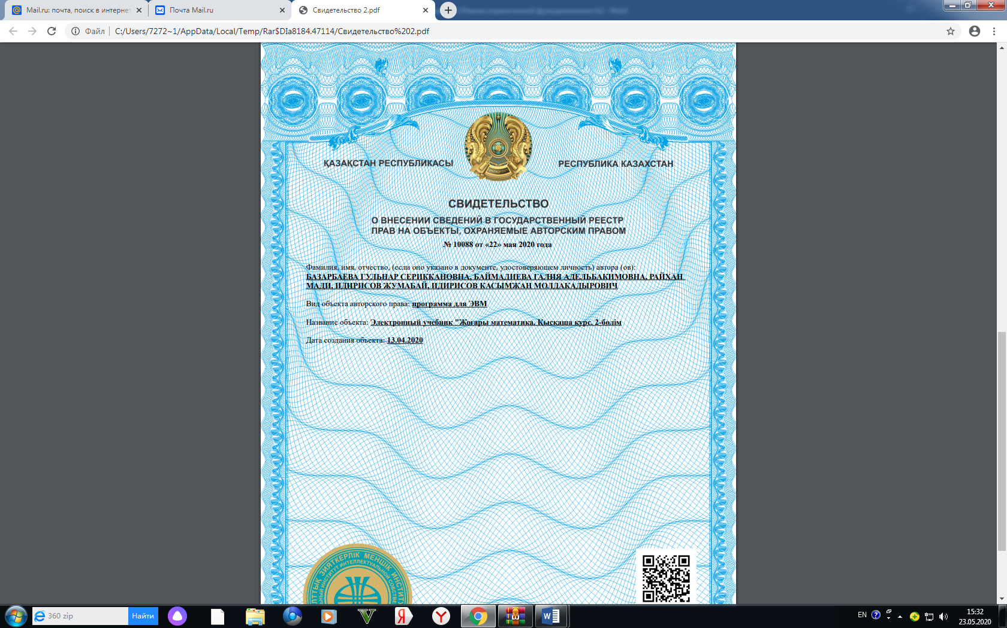

1) An electronic textbook "Higher mathematics- Part II" has been published.
Received a certificate of entering information in the State Register of rights to objects protected by copyright No. 3675 dated May 29, 2019.

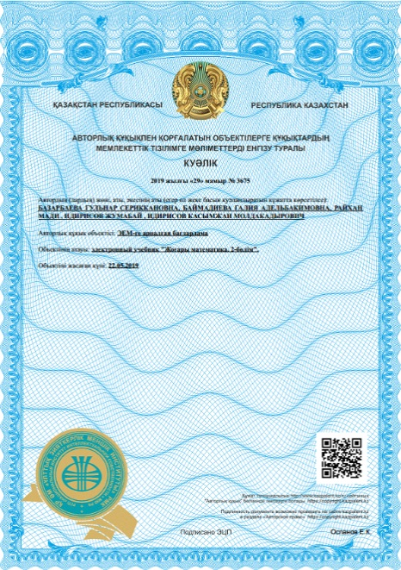

2) Issued electronic textbook
1. Higher mathematics. Short course. Part 1. Electronic textbook. Copyright. Certificate No. 9991. 19.05.2020. (Co-authored)

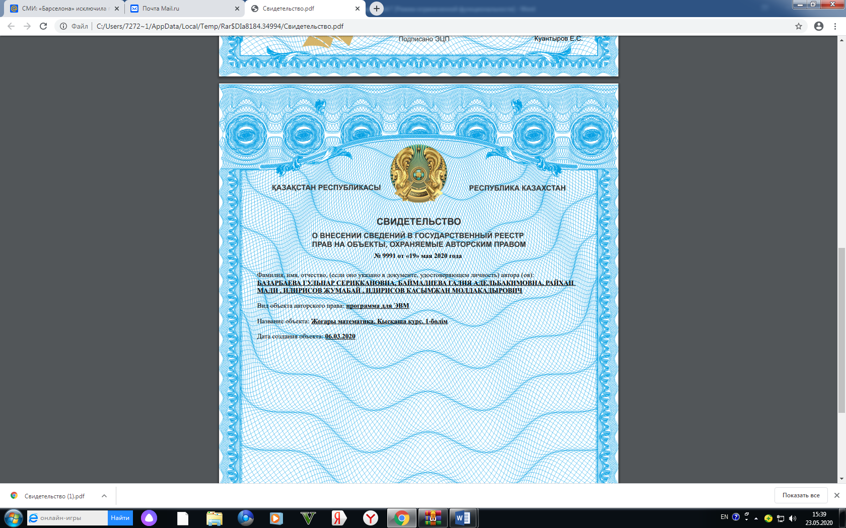

3) Issued electronic textbook

2. Higher mathematics. Short course. Part 2. Electronic textbook. Copyright. Certificate No. 10088. 22.05.2020 (Co-authored)

Note: data on professional development, scientific publications and developments should be submitted for the last 5 years.

